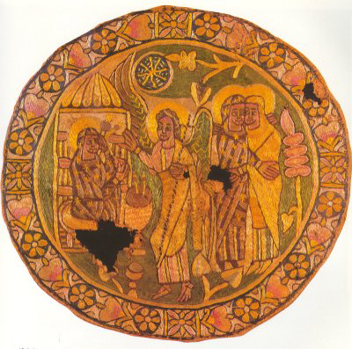
A Ninth Century Feast

Appetizer
Mock Venison Pie with Juniper

Soup
Haddock and Lentil Stew
Served with
Oat Griddle Cakes

Entrées
Roasted Fowl Two Ways
Roasted Fish with Green Sauce
Served with
Barley Browis
Honey Glazed Carrots and Parsnips
and Honey Cakes

Dessert
Lavender Scented Pudding
and
Baked Apples

Beverages will include Mead and Ice Wine

